Create Table Exercise

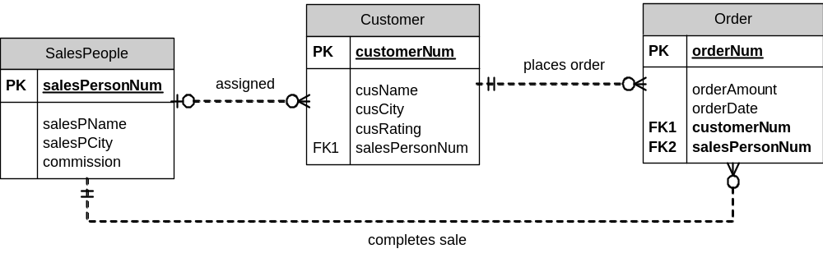

Create a table “SalesPeople” with the following columns:
- salesPersonNum is a four digit integer that uniquely identifies each sales person
- salesPName is a character type, with up to 15 characters – all sales people will have a value set for salesName.
- salesPCity is a character type, with up to 15 characters – it may be left blank
- commission is a decimal type – with up to 2 decimal places – it may be left blank – the default value is 0.10 – must contain a value less than 1 but greater than 0.

Sample data:
salesPersonNum | salesPName | salesPCity | commission
1001 | Peel | London | .12
1002 | Serres | San Jose | .13
1004 | Motika | London | .11
1007 | Rifkin | Barcelona | .15
1003 | Axelrod | New York | .10

Create a table “Customer” with the following:
- customerNum is a four digit integer that uniquely identifies each customer
- cusName is a character type, with up to 15 characters – must have a value
- cusCity is a character type, with up to 15 characters – may be blank
- cusRating is a three-digit integer type – may be blank
- salesPersonNum will refer to a value in the SalesPeople table – it may be blank.

Sample data:
CustomerNum | cusName | cusCity | cusRating | salesPersonNum
2001 | Hoffman | London | 100 | 1001
2002 | Giovanni | Rome | 200 | 1003
2003 | Liu | San Jose | 200 | 1002
2004 | Grass | Berlin | 300 | 1002
2006 | Clemens | London |  | 1001
2008 | Cisneros | San Jose | 300 | 1007
2007 | Pereira | Rome | 100 | 1004

Create a table “Orders” with the following:
(Note: The ERD is incorrectly marked, Order should be Orders)
- orderNum is a four digit integer that uniquely identifies each order
- orderAmount is a fixed-point number with two decimal places and up to 9 digits in total – must have a value
- orderDate is a date type – must have a value
- customerNum is a reference to the customer that placed this order – must have a value
- salesPersonNum is a reference to the sales person who helped with this order – the salesPersonNum here may be different than the salesPersonNum assigned for the customer. salesPersonNum may be blank

Sample data:
orderNum | orderAmount | orderDate | customerNum | salesPersonNum
3001 | 18.69 | 10/03/2000 | 2008 | 1007
3003 | 767.19 | 10/03/2000 | 2001 | 1001
3002 | 1900.10 | 10/03/2000 | 2007 | 1004
3005 | 5160.45 | 10/03/2000 | 2003 | 1002
3006 | 1098.16 | 10/03/2000 | 2008 | 1007
3009 | 1713.23 | 10/04/2000 | 2002 | 1003
3007 | 75.75 | 10/04/2000 | 2004 | 1002
3008 | 4723.00 | 10/05/2000 | 2006 | 1001
3010 | 1309.95 | 10/06/2000 | 2004 | 1002
3011 | 9891.88 | 10/06/2000 | 2006 | 1001

Don’t make these changes to Orders, but consider how you’d do it:
- What if all combinations of customerNum and salesPersonNum have to be different from each other?

- What if we wanted a rule that the orderNum is greater than the customerNum, and the customerNum is greater than the salesPersonNum? (Yes, not a practical rule, but it can be done.)

- What if we wanted to add a column “previous” to Orders that would hold the orderNum of the previous order placed by this customer (or null, if this was the first order by this customer)? Implement this with a foreign key.

Alter Table

- Remove the commission column from SalesPeople.
- Add a column maxSale to SalesPeople that has a default of 0 and can store a maximum value of 999,999.99
- Allow salesPName to be blank.
- Add a default date of January 1st, 2012 for OrderDate.

